7. Regex Validation Rules Continue and Page Layout - 03 March 2022

<https://www.jadeglobal.com/blog/implementation-regex-salesforce>

1] Prevent invalid PAN Card.

Correct 🡪 AVTPO6765R (Pattern)

REGEX (Regular Expression)

NOT( REGEX( PAN_CARD__c , "[A-Za-z]{5}[0-9]{4}[A-z]{1}") )



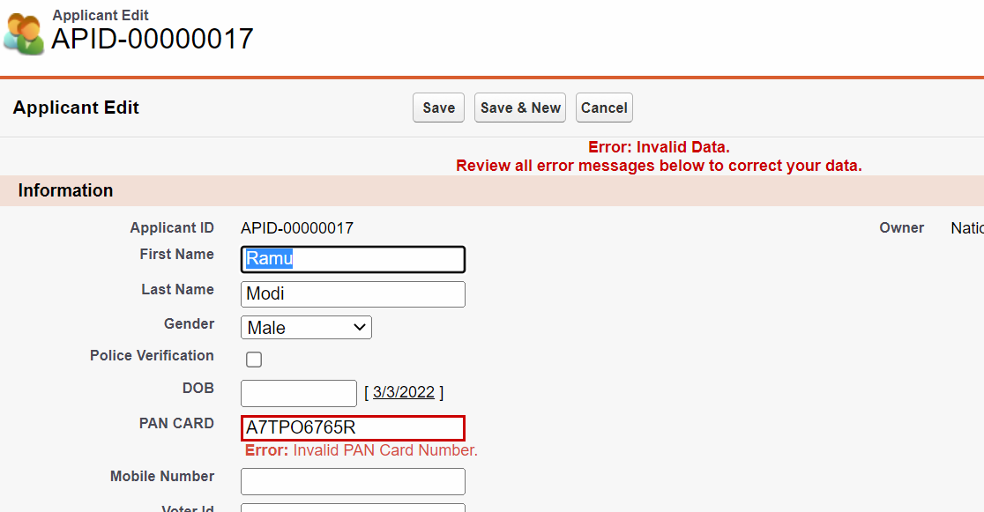

2] Prevent Special Symbols or Numbers in First Name OR Last Name.

REGEX 🡪

OR(

NOT(REGEX( First_Name__c ,"^[a-z A-Z]*$")) ,

NOT(REGEX( Last_Name__c ,"^[a-z A-Z]*$"))

)

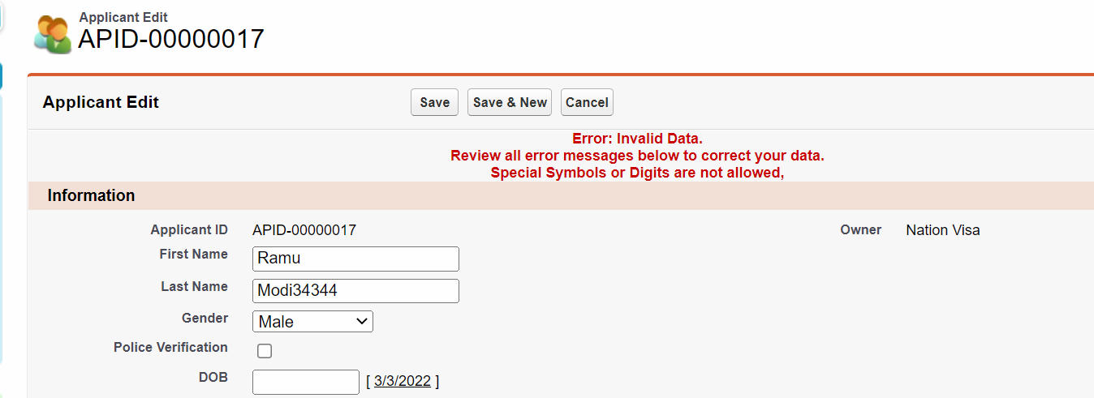

3] Prevent Invalid Email ID.

NOT(REGEX( Email_Id__c ,'([a-zA-Z0-9_\\-\\.]+)@((\\[a-z]{1,3}\\.[a-z]{1,3}\\.[a-z]{1,3}\\.)|(([a-zA-Z0-9\\-]+\\.)+))([a-zA-Z]{2,4}|[0-9]{1,3})'))

Assignment:

1] Prevent Account is Type is “Prospect” OR “Customer - Direct” and Rating is “Hot” or “Warm”

And Account Name starts with “A”.

2] Prevent Account Type “Prospect” or “Customer - Direct” and Rating “Hot” and SLA “Gold”.

- Account Type “Prospect” or “Customer - Direct”

- Rating “Hot”

- SLA “Gold”

3] Prevent Record If,

1] Age < 18 and Gender is “Female”

Or

3] Age =30 and Gender is “Male”

4] Prevent First Name if not start with “B”.

==========================================================================

Page Layout

A Page layout is used to,

1] Design the Details / Edit Page as per the need.

2] Show / Hide the fields.

3] Mandatory a field.

4] Show different Details Pages to Different types of users.

1] Design the Details / Edit Page.

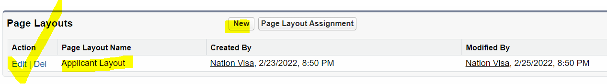

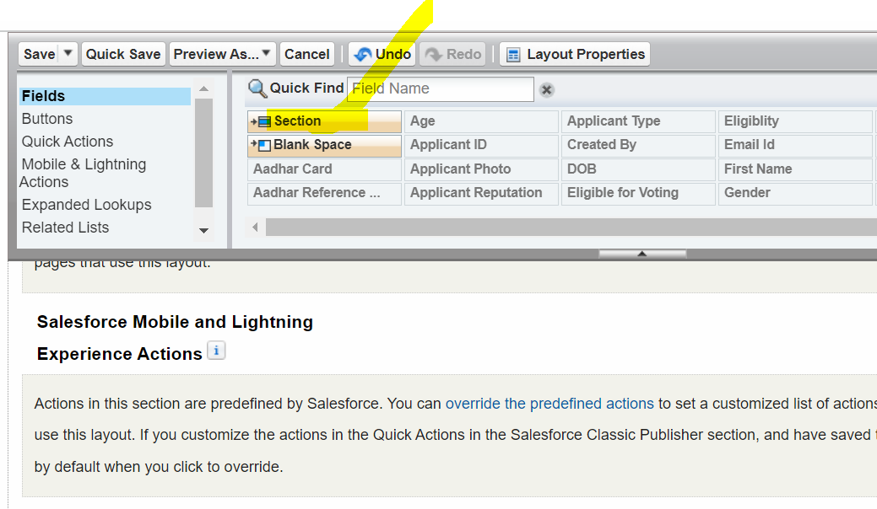

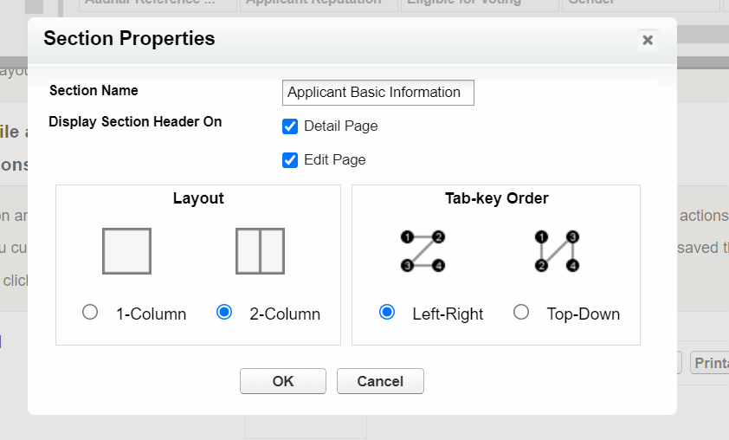

2] Show / Hide the fields.

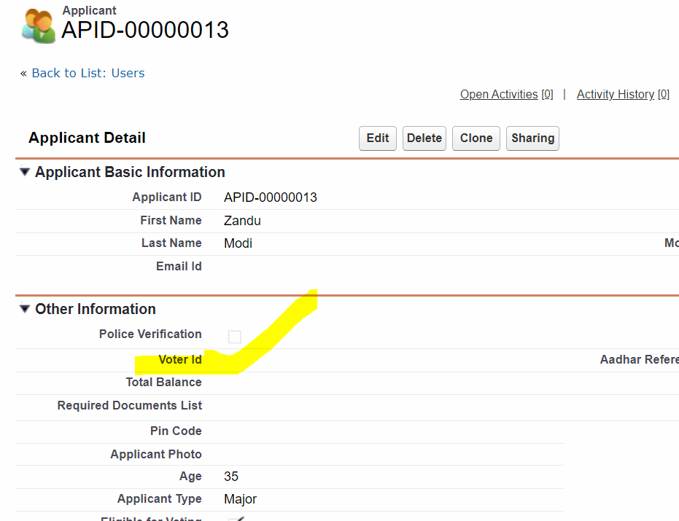

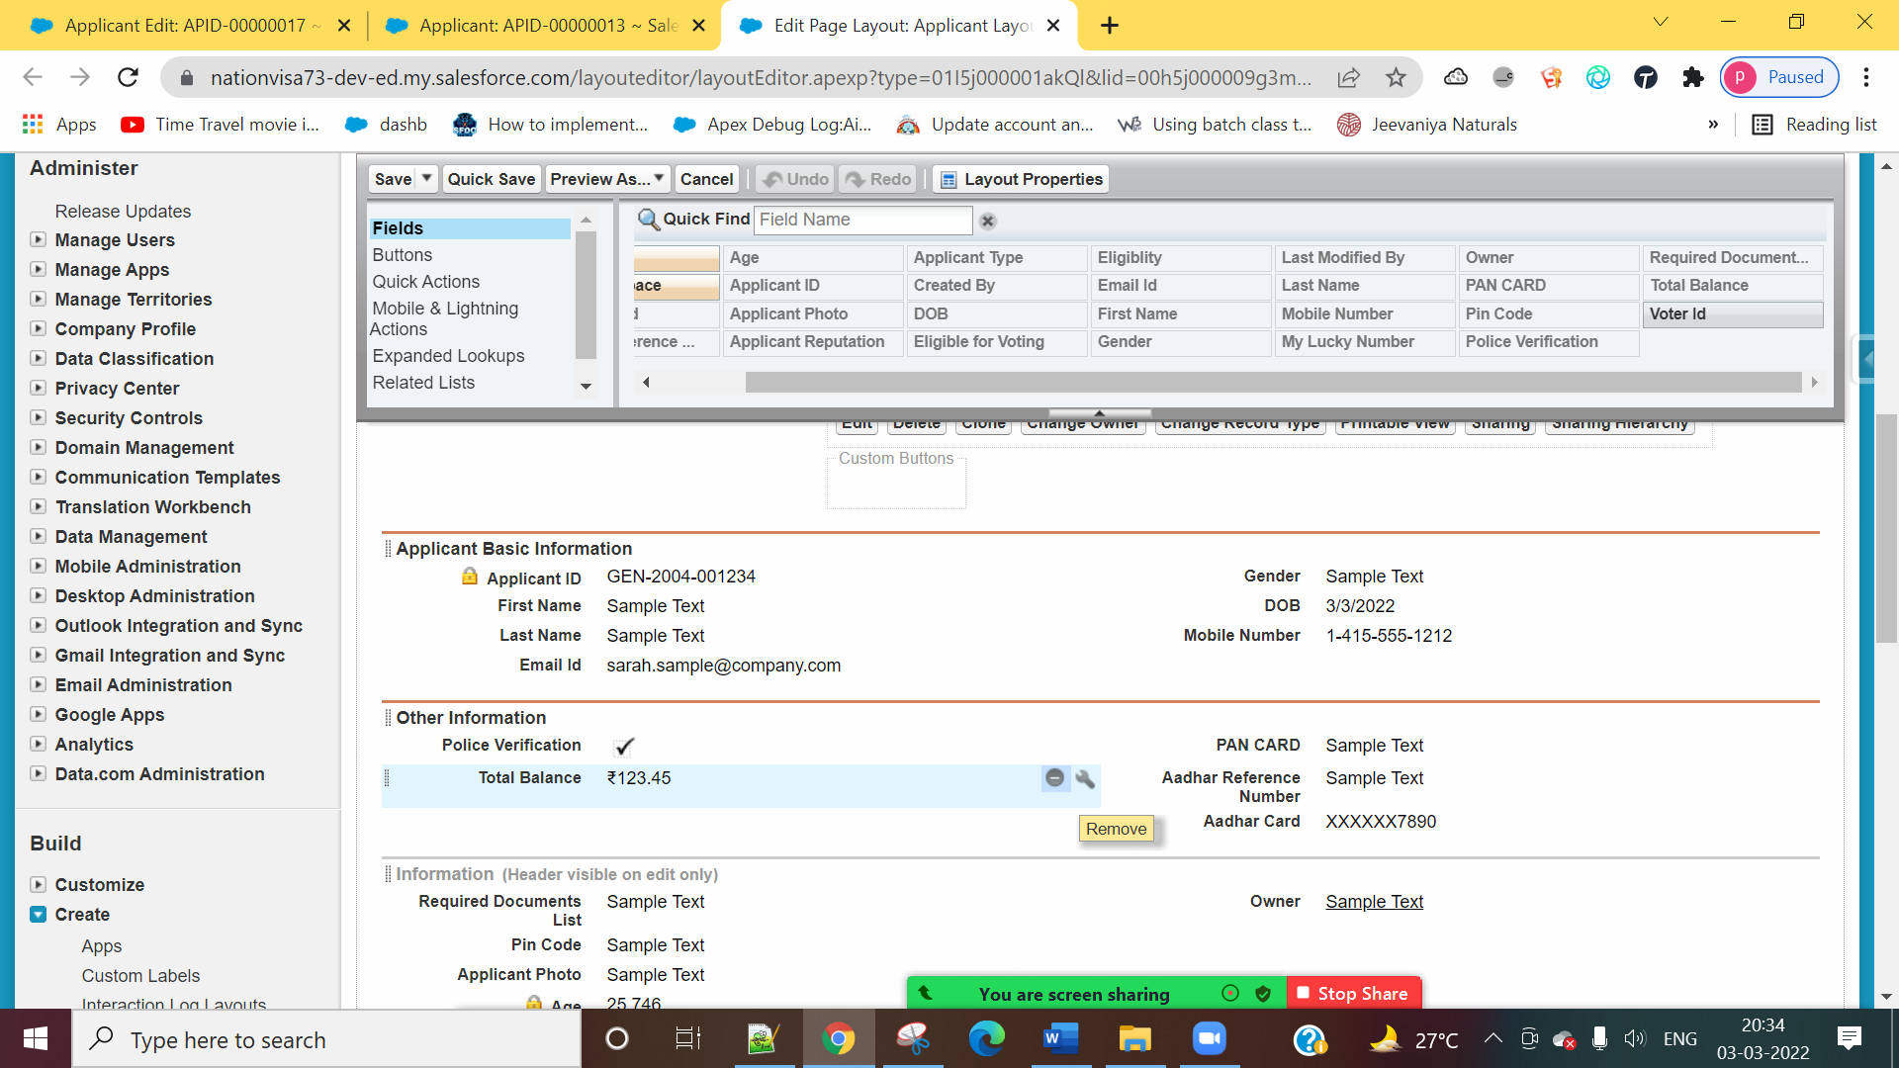



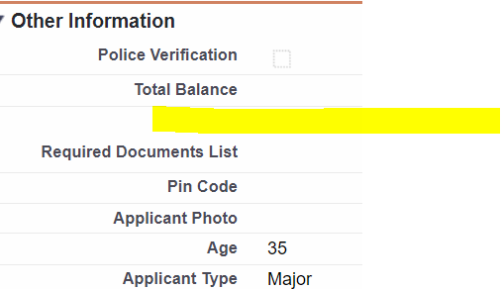

3] Mandatory a field.

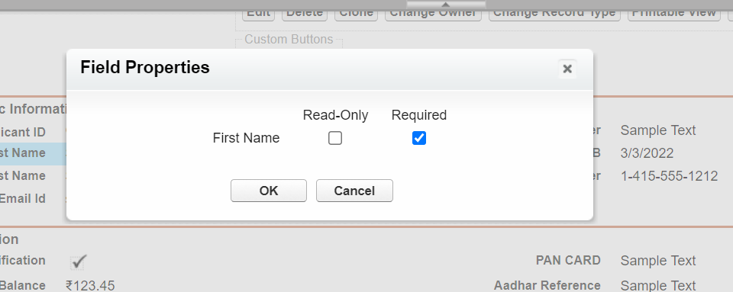

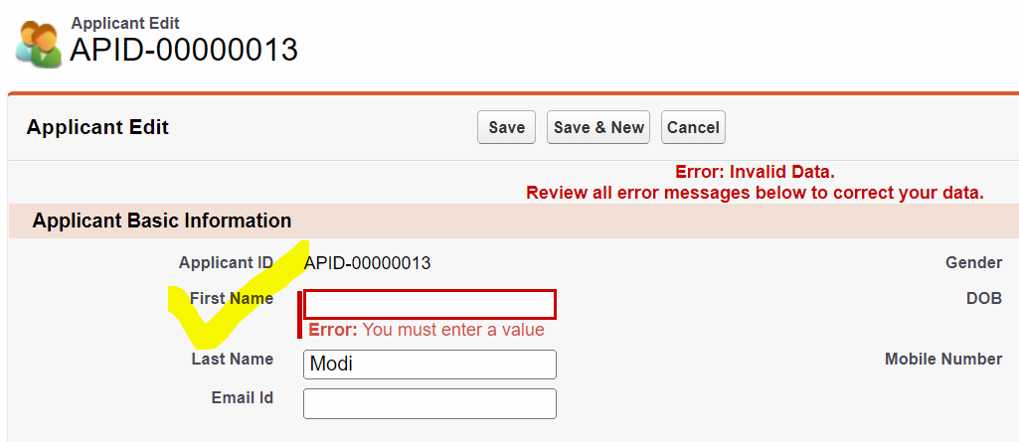

4] Show different Details Pages to Different types of users.

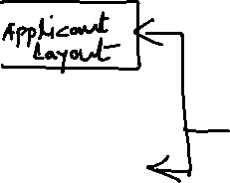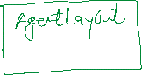

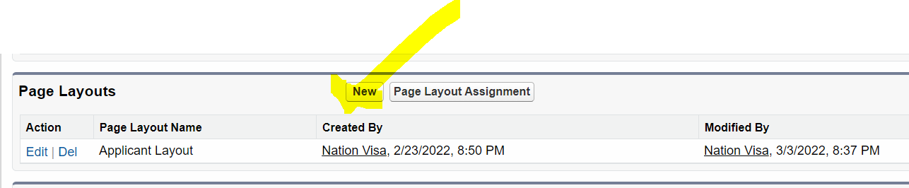

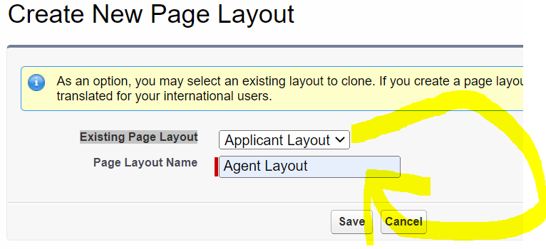

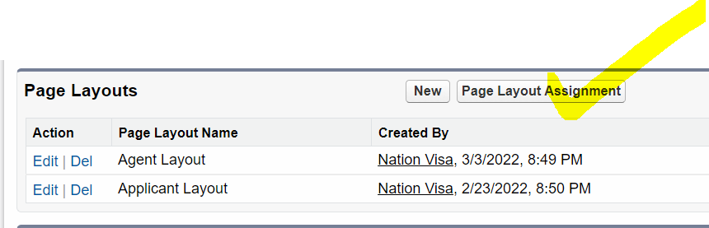

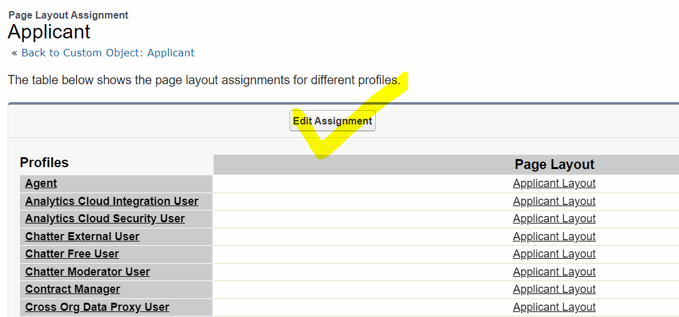

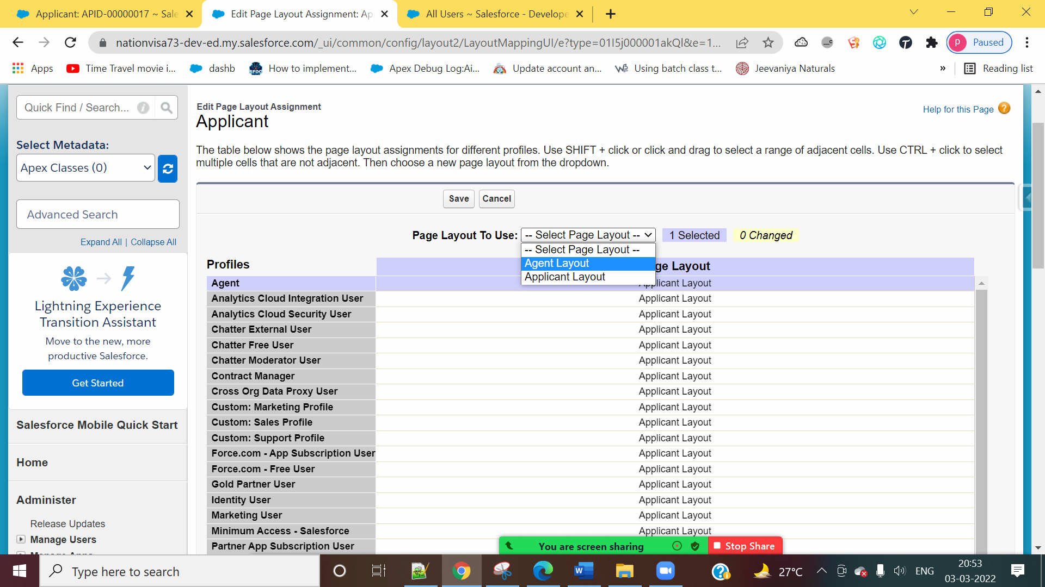

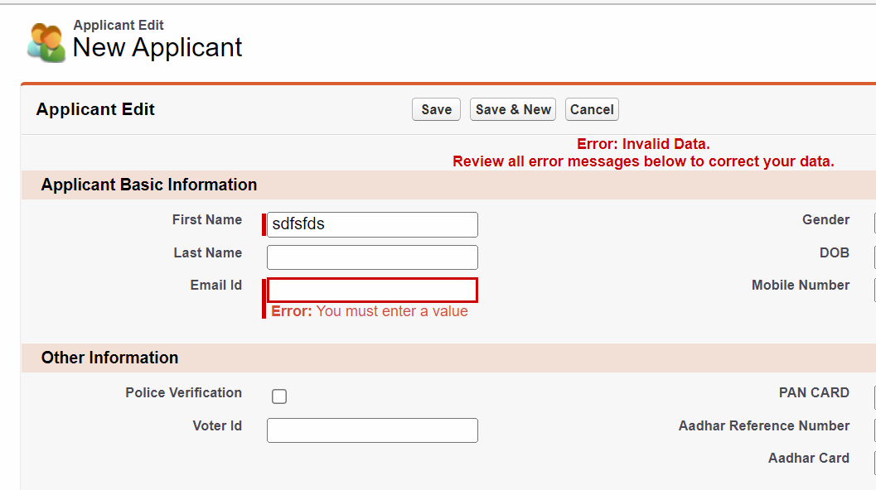

Validation Rule (Bhedbhav Wala)

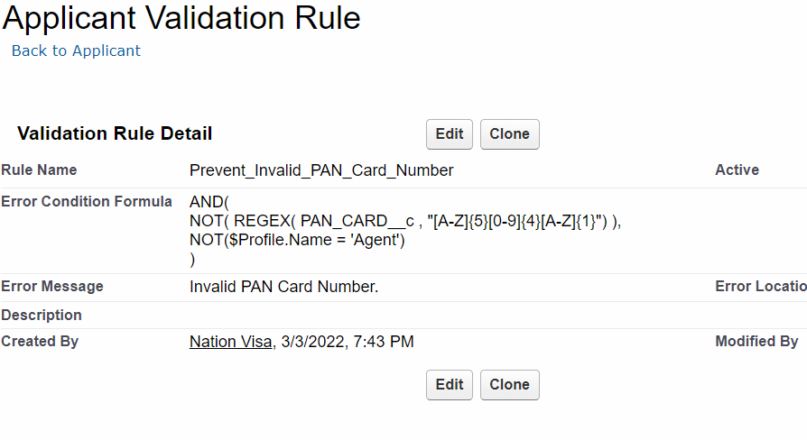

Assignment:

There are Three Profile, System Admin, Agent, Manager

Requirement.

1] Only System Admin and Agent should be able to see the Email ID field.

2] Email Id is mandatory for Agent.

3] Only Manager can see the Amount field.